**PROJECT SYNOPSIS**

**of**



Bank Management System

**Submitted by :**

Ashok Gupta

Id : AF0350761

Batch Code : ANP-C6985

**Submitted to :**

Mr. Anuj Kumar

|  |  |  |
| --- | --- | --- |
| S.no | Topic | Page no |
| 1 | Introduction | 3 |
| 2 | Technologies and Tools | 5 |
| 3 | System Requirement Specifications | 7 |
| 4 | Benefits and Limitations | 8 |
| 5 | Database Design | 9 |
| 6 | Screenshots | 13 |
| 7 | Conclusion | 17 |

**INDEX**

**1.INTRODUCTION**

Bank Management System Console Version is your comprehensive solution for managing your finances and banking needs. In today's fast-paced world, we understand the importance of making banking accessible and hassle-free. With our console-based platform, you can conveniently handle all your financial transactions from the comfort of your home.

Think of Bank Management System Console as your personal banking assistant, available at your fingertips whenever you need it. Whether you're looking to save, borrow, or invest, our platform offers seamless digital solutions to meet your requirements.

One of the greatest advantages of our console-based system is its versatility. You can access your bank account and perform transactions from any compatible device, whether it's your computer, tablet, or smartphone. This flexibility ensures that you can bank whenever and wherever it's convenient for you.

At Bank Management System Console, simplicity is key. We provide intuitive tools and top-notch security features to ensure that managing your money is both easy and secure. Whether you need to check your account balance or make significant financial decisions, our platform has you covered.

Our commitment is to offer you the best banking experience possible. We strive to make managing your finances as effortless and secure as possible, allowing you to focus on what truly matters to you.

Join us at Bank Management System Console as we redefine the banking experience, leveraging technology to empower you and make your financial life easier and more enjoyable than ever before.

**Key features of Bank Management System:**

**1. Account Customization:** Tailor your banking experience to your specific needs with our Account Customization tool. Choose from various account types and features to create the perfect banking setup that fits your financial goals.

**2. Integration with Financial Communities:** Connect with financial communities and access valuable insights and advice from fellow users. Our integration with financial forums allows you to stay informed about the latest trends and innovations in the banking world while seeking guidance on managing your finances effectively**.**

**3. Exclusive Offers:** Enjoy exclusive offers and discounts on banking products and services curated specifically for our BankEasy members. Benefit from special promotions and savings opportunities to enhance your banking experience.

**4. Financial Advisory Services:** Schedule personalized sessions with our team of financial experts for tailored financial advice and assistance. Whether you're new to banking or an experienced investor, our experts are here to address your queries and provide recommendations to help you achieve your financial goals.

**5. DIY Financial Planning Guides:** Empower yourself to take control of your finances with our comprehensive DIY Financial Planning Guides. From budgeting to investment strategies, our guides provide step-by-step instructions to help you manage your money effectively.

**6. Seamless Banking Across Devices:** Experience seamless access to your accounts and banking services across multiple devices with our Cross-Platform Sync feature. Your banking information is synchronized in real-time, allowing you to manage your finances wherever you are, whether on your computer, tablet, or smartphone.

**7. Localized Payment Options:** Choose from a variety of payment methods tailored to your region, ensuring a convenient and hassle-free banking experience. Our localized payment options accommodate diverse customer preferences, allowing you to conduct transactions with confidence.

**8. Real-Time Account Updates:** Stay informed about your account activity with our Real-Time Account Updates feature. We provide automatic updates on account balances, transactions, and other important information to help you stay on top of your finances and make informed decisions.

**2.TECHNOLOGIES AND TOOLS**

**1. Core Java:**

Core Java is a foundational course essential for mastering Java programming. It covers syntax, data types, control structures, and object-oriented principles. Students learn to create classes, implement inheritance, polymorphism, and interfaces. Additionally, they explore topics like exception handling, collections, file I/O, multithreading, and networking. Mastery of Core Java equips students to develop robust Java applications and advance in their programming careers.

**2. JPA (Java Persistence API):**

The JPA (Java Persistence API) course offers a structured approach to database interaction in Java applications. Students learn the basics of entity mapping, persistence context handling, and querying through JPQL. The curriculum covers entity and relationship definition, CRUD operations, and transaction management for data integrity. Advanced topics include caching, lazy loading, and criteria queries. Mastery of JPA empowers students to develop efficient and scalable Java applications seamlessly integrated with databases.

**3. Hibernate:**

Hibernate simplifies Java application development by offering an object-relational mapping solution. This course covers entity mapping, session management, and querying with HQL. Students learn to define persistent entities, perform CRUD operations, and explore advanced topics like caching and lazy loading. Mastery of Hibernate enables developers to build efficient and scalable Java applications with seamless database integration.

**4. MySQL :**

MySQL forms the backbone of the Bank Management System, serving as its relational database management system (RDBMS). It securely stores critical data related to customer accounts, transactions, and banking operations. JPA and Hibernate frameworks facilitate seamless interaction with MySQL, enabling efficient data management processes. Through SQL queries and statements, developers can efficiently handle data persistence, retrieval, and manipulation, ensuring the reliability and security of the banking platform..

**Server used :**

**IDE used:**

* **Eclipsed IDE :** Eclipse IDE is the primary development environment for Bank Management System. It facilitates coding, debugging, testing, and project management. Eclipse seamlessly integrates with version control systems like Git and supports build automation for deployment. Its extensive plugin ecosystem enhances productivity and customization for the development team. In summary, Eclipse IDE serves as a comprehensive toolset for efficient and streamlined development of the Bank Management System.

**3. SYSTEM REQUIREMENTS SPECIFICATIONS**

* **Hardware and Software Requirement :**

For a minimal setup to host the Krypturg e-commerce platform:

**Hardware :**

**1.Server:**

* + - **CPU:** Dual-core processor
    - **RAM:** 8GB DDR4
    - **Storage:** 250GB HDD or SSD
    - **Network:** Ethernet connectivity

**2.Database Server:**

**CPU:** Dual-core processor

**RAM:** 8GB DDR4

**Storage:** 250GB HDD or SSD

**3.Networking Equipment:**

Basic router

Ethernet switch

**Software:**

**1.Operating System:**

Windows/MAC

**2.Database Management System:**

MySQL as the relational database management system (RDBMS) for storing product information, user data, and transaction records**.**

**4.Integrated Development Environment (IDE):**

* + - Eclipse IDE for Java EE development.

This combined hardware and software configuration forms the basic infrastructure required to deploy and operate the Bank Management System. Additional resources and optimizations may be necessary based on the scale and requirements of the project.

**4.BENEFITS AND LIMITATIONS :**

**Benefits of Bank Management System**:

**1. Efficiency and Accessibility:** Streamlined banking processes for faster account management and transactions, enhancing customer experience**.**

**2. 24/7 Availability:** Allows customers to perform banking tasks at any time, ensuring round-the-clock access to essential services**.**

**3. Expanded Reach:** Overcomes geographic limitations, enabling banks to serve customers from diverse locations and broaden their market reach.

**4. Cost Savings:** Lower operational costs compared to physical branches, resulting in improved cost efficiency and profitability.

**5. Enhanced Customer Support:** Provides personalized assistance through features like interactive prompts and error handling, ensuring quality service delivery**.**

**6. Simplified Operations:** Easy setup and management of banking operations with minimal resource requirements, offering flexibility and ease of management.

**Limitations :**

**1. Limited Transaction Visibility**: Customers lack real-time visibility into their transactions and account balances, potentially causing confusion or dissatisfaction.

**2. Accessibility Constraints:** Dependency on physical presence or phone-based interactions may limit accessibility for customers with mobility or communication challenges.

**3. Security Concerns:** Risks of unauthorized access or fraud due to reliance on manual processes and lack of robust security measures.

**4. Transaction Processing Delays:** Manual handling of transactions may result in delays or errors, impacting customer satisfaction and operational efficiency**.**

**5. Limited Service Offerings**: Inability to offer complex banking services or personalized experiences typically available in online or branch-based banking systems**.**

**6. Dependency on Human Resources**: Reliance on manual data entry and processing increases the likelihood of errors and operational inefficiencies.

**Database Design**

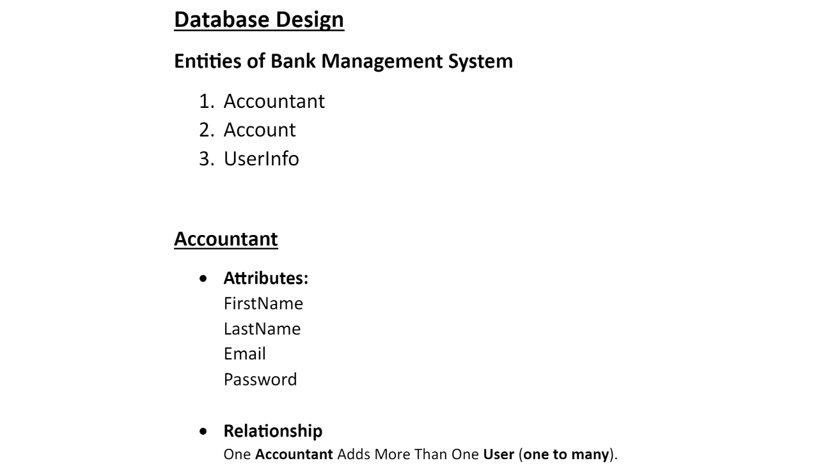

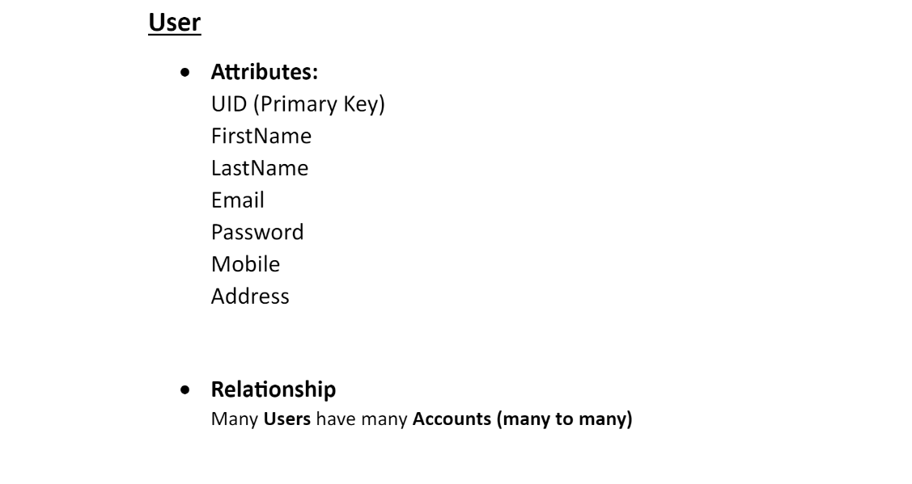

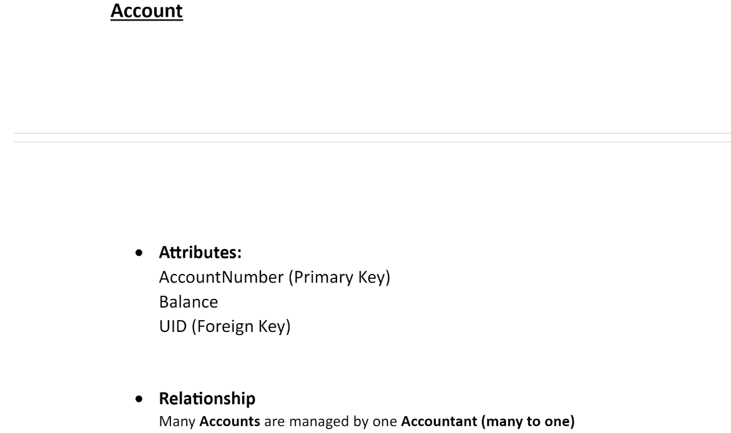

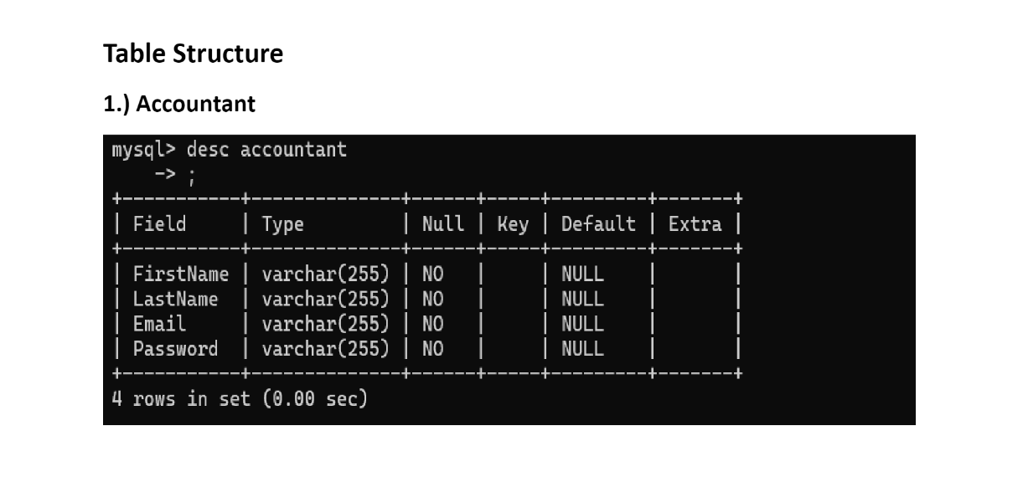

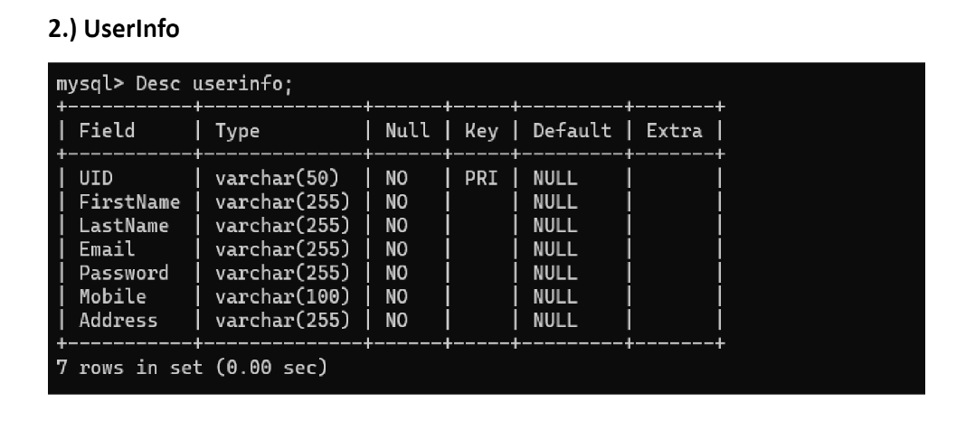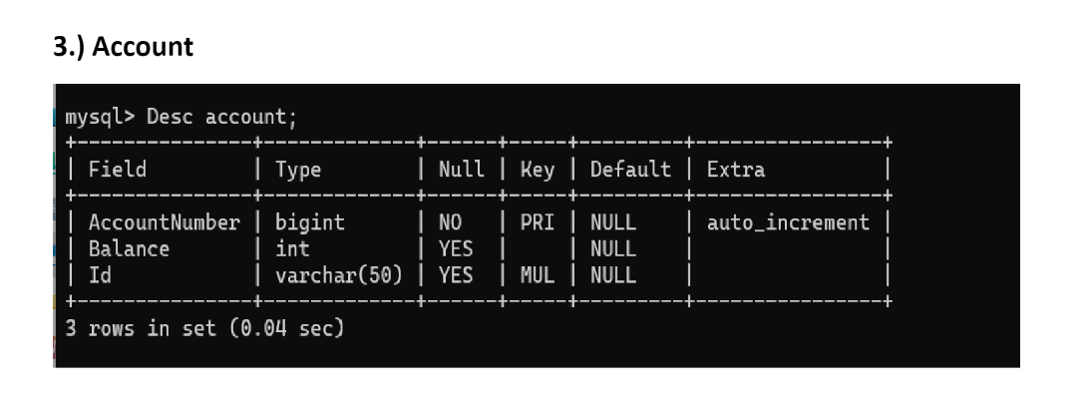

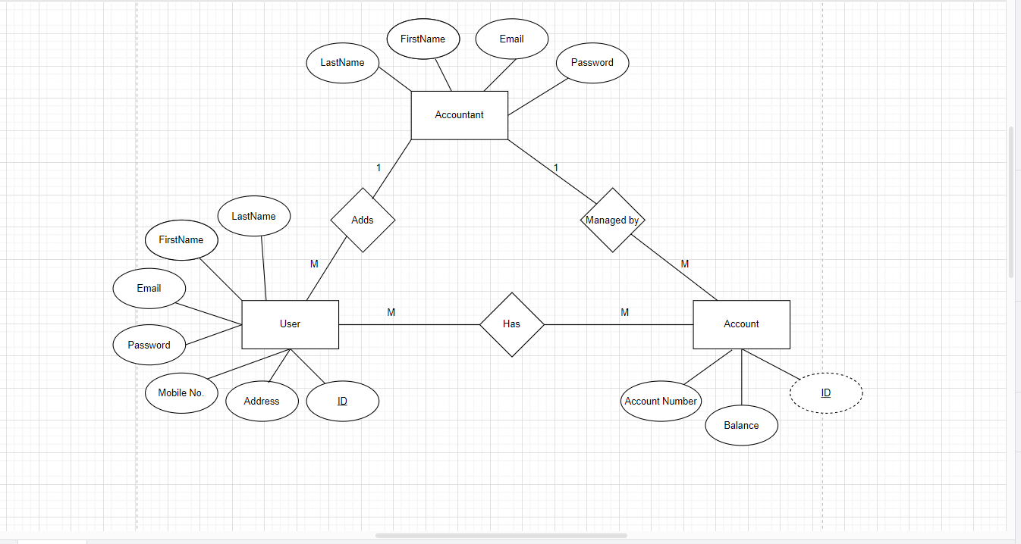

**6.SCREENSHOTS :**

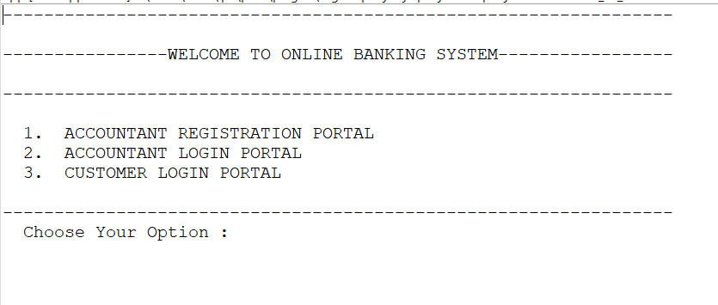

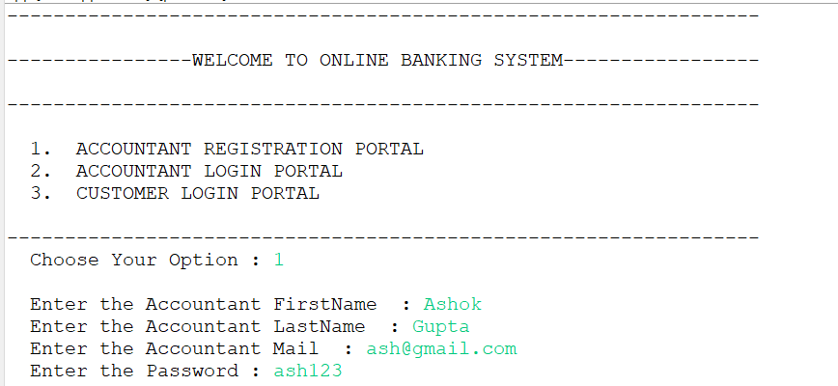

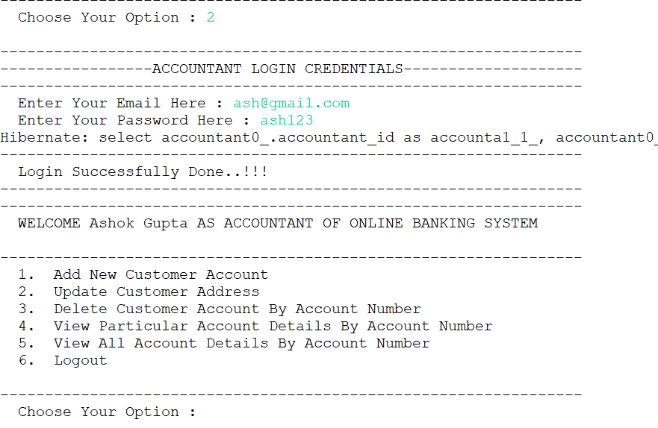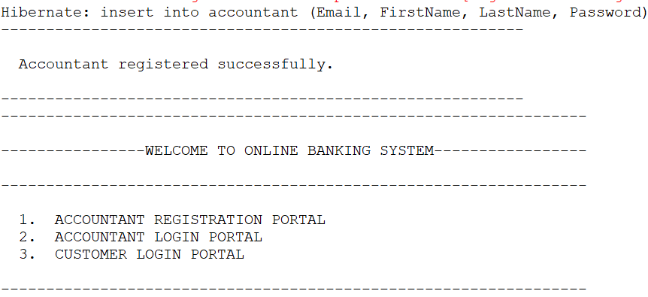

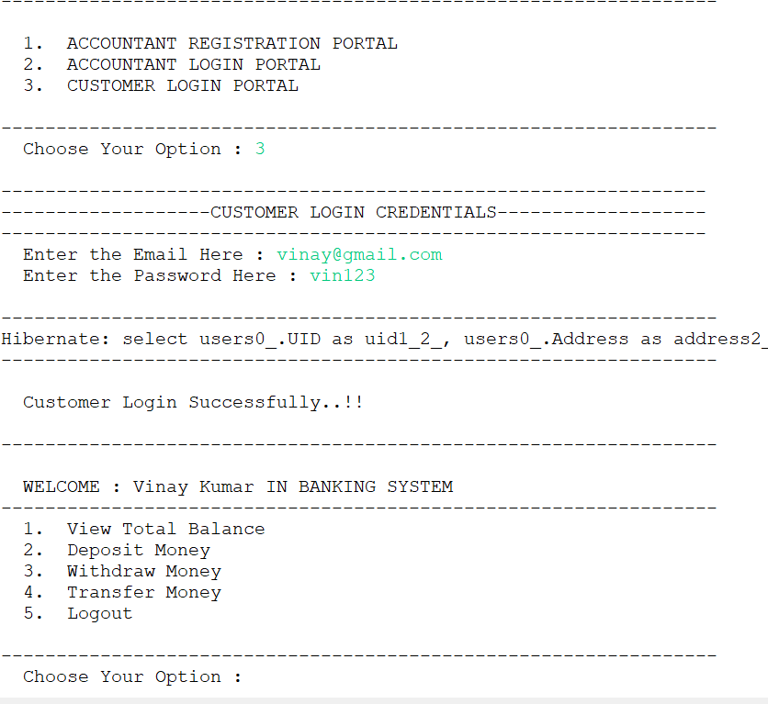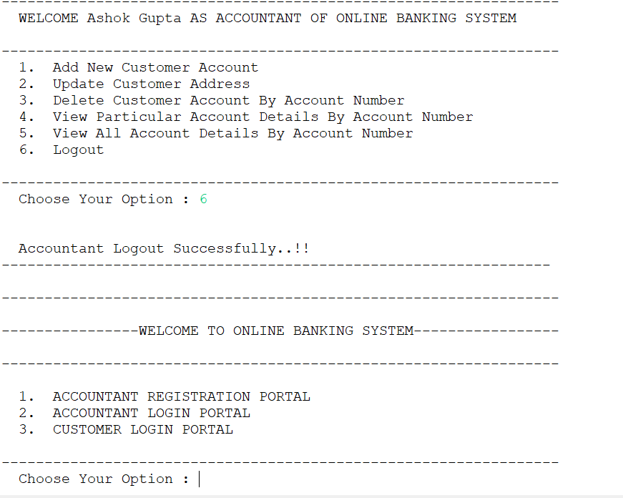

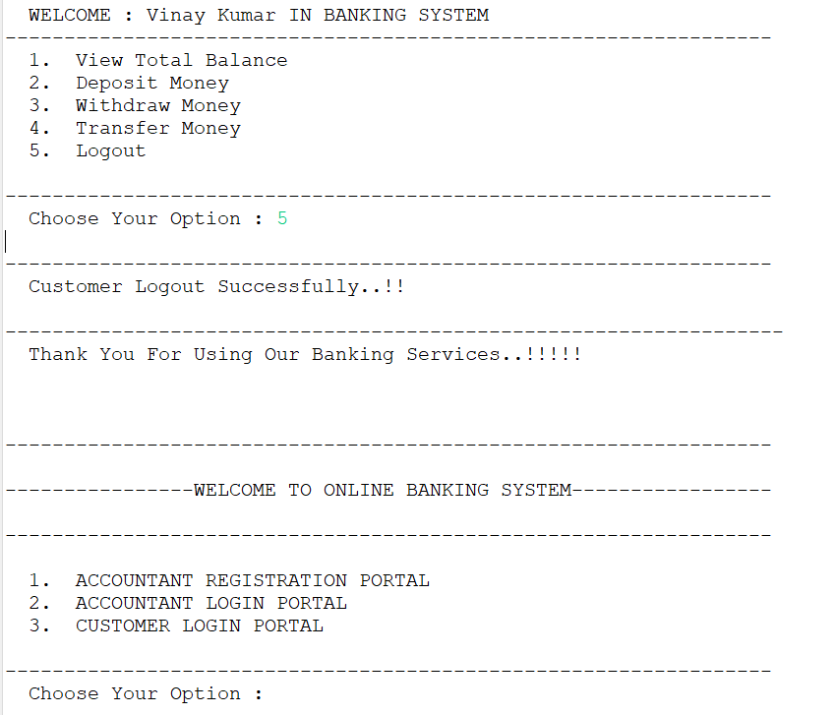

**7.CONCLUSION**

In conclusion, the Console-Based Bank Management System serves as a reliable platform for managing banking operations efficiently. With its streamlined functionalities like account management and transaction processing, the system aims to provide a convenient and secure banking experience. While the main objective is to enhance operational efficiency and customer satisfaction for the bank, the Console-Based Bank Management System showcases the potential of console-based solutions in meeting diverse banking needs in today's technological landscape.